Module Name: Login Page – Functional & UI Test Cases
Test Case ID: TC_01
Tester Name: Desai Mohit
Webpage Name: Instagram Clone Login Page
Technology Used: HTML, CSS, JavaScript
IDE: Visual Studio Code
Browser: Google Chrome

Scenario ID: 1a

Scenario:Login with Valid Credentials

Test Steps:

- Open the Instagram Clone Login Page.

- Enter a valid username.

- Enter a valid password.

- Click on the Login button.

Test Input:

Username: test123
Password: Test@123

Expected Result:

The user should be logged in successfully and redirected to the Home Page.

Actual Result:

The user was successfully logged in and redirected to the Home Page.

Status:

PASS

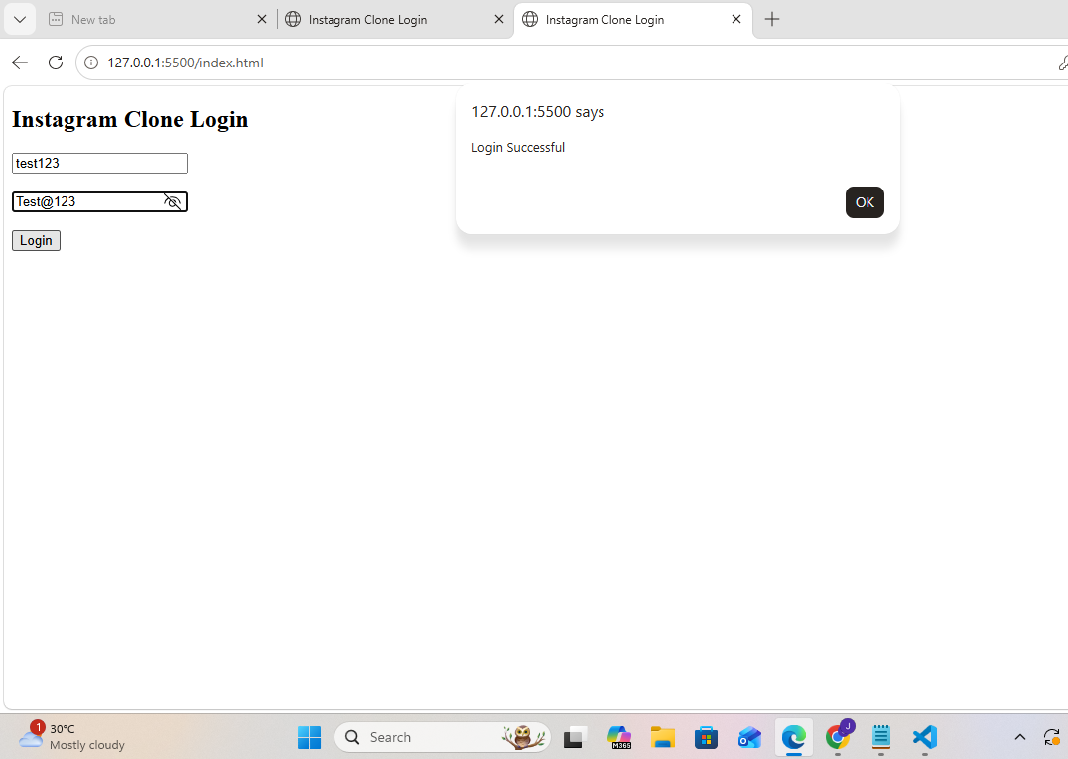

Scenario ID: 1b

Scenario: Login with Invalid Username

Test Steps:

- Open the Login Page.
- Enter an invalid username.
- Enter the correct password.
- Click on Login.

Test Input:

Username: abc123
Password: Test@123

Expected Result:

An error message should be displayed.

Actual Result:

"Invalid Username or Password" message displayed.

Status:

PASS

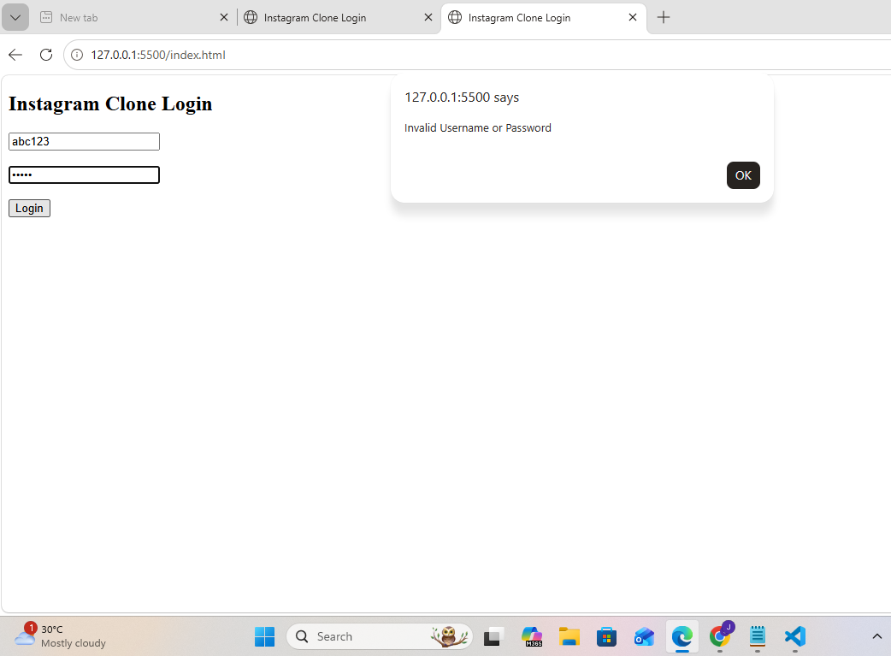

Scenario ID: 1c

Scenario: Login with Invalid Password

Test Steps:

- Open Login Page.
- Enter a valid username.
- Enter an incorrect password.
- Click Login.

Test Input:

Username: test123
Password: 12345

Expected Result:

The system should display an error message.

Actual Result:

Login failed and error message displayed.

Status:

PASS
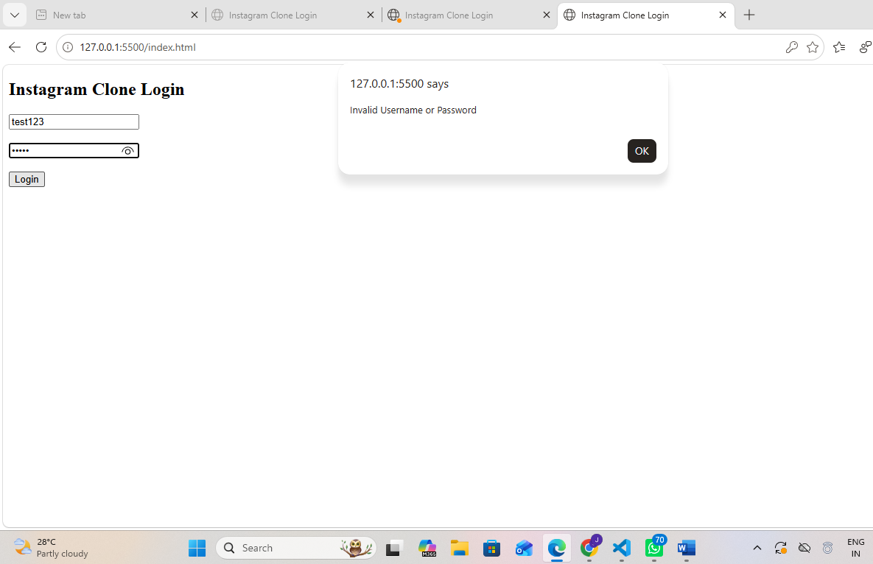

Test Case Summary

Summary of Test Results

Parameter Result

Total Test Cases 20

Passed 20

Failed 0

Pass Percentage 100%

Observations

- Login page loaded successfully.

- Valid login redirected to the home page.

- Invalid username and password displayed proper error messages.

- Input validation worked correctly.

- User interface was responsive and easy to use.

Conclusion

Conclusion

The Instagram Clone Login Page was successfully developed and tested using HTML, CSS, and JavaScript. All functional and UI test cases were executed successfully. The application validated user credentials correctly, displayed appropriate error messages for invalid inputs, and provided a responsive user interface. Based on the testing performed, the application met the expected functional requirements.

Future Scope

- Forgot Password feature

- Remember Me option

- Email Verification

- Two-Factor Authentication (2FA)

- Database Integration

6 .Enhanced security features

Scenario ID: 1d

Scenario: Login with Empty Username

Test Steps:

- Open the Login Page.
- Leave the Username field blank.
- Enter a valid Password.
- Click on Login.

Test Input:

Username: Blank
Password: Test@123

Expected Result:

The system should display "Username Required".

Actual Result:

Username Required message displayed.

Status:

PASS
Scenario ID: 1e
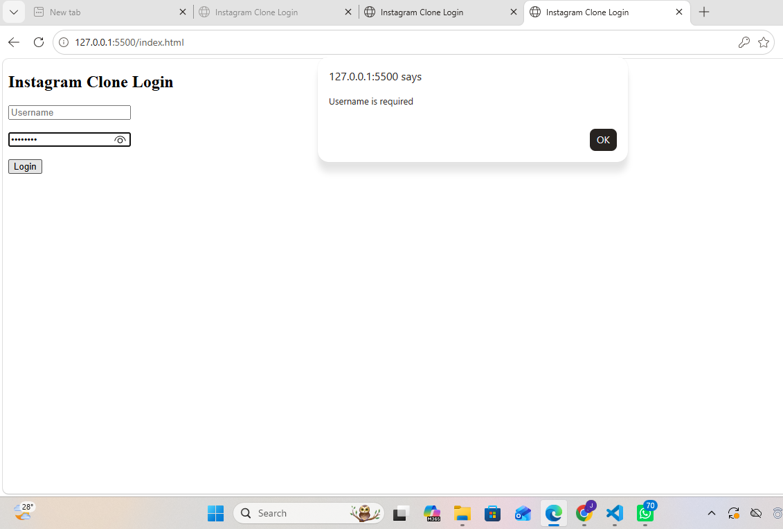

Scenario ID:1e

Scenario: Login with Empty Password

Test Steps:

- Open the Login Page.
2. Enter a valid Username.
3. Leave the Password field blank.
4. Click Login.

Test Input:

Username: test123
Password: Blank

Expected Result:

Password Required message should be displayed.

STATUS:
PASS

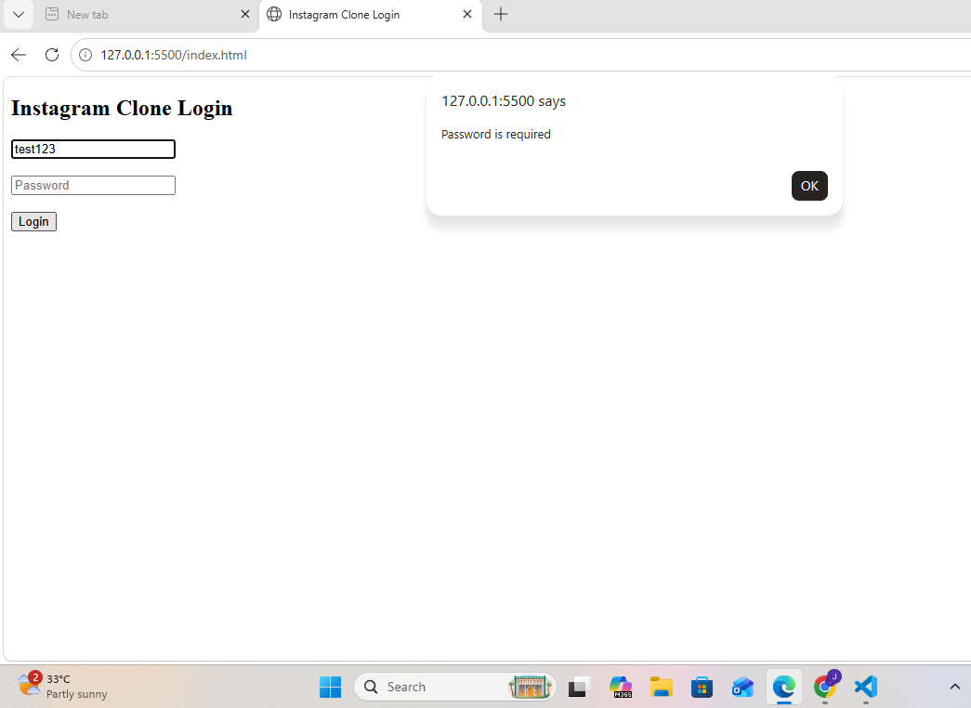

Scenario ID: 1f

Scenario: Login with Empty Fields

Test Steps:

- Open the Login Page.
- Leave Username blank.
- Leave Password blank.
- Click Login.

Test Input:

Blank Username & Password
Expected Result:

Validation message displayed.

Actual Result:

Validation message displayed.

Status:

PASS

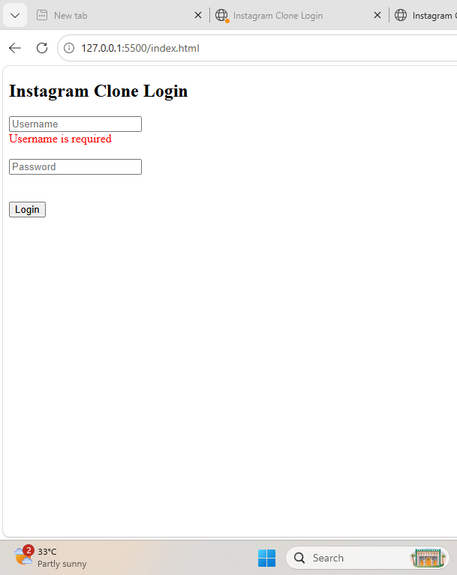

Scenario ID: 1g

Scenario: Check Password Visibility Toggle

Test Steps:

- Enter Password.
- Click on Eye Icon.

Test Input:

Password Field

Expected Result:

Password becomes visible.

Actual Result:

Password becomes visible.

Status:

PASS
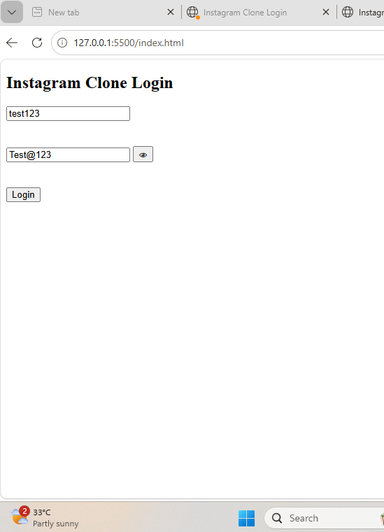

Scenario ID: 1h

Scenario: Login Using Username with Spaces

Test Steps:

- Enter Username with spaces.
- Enter Password.
- Click Login.

Test Input:

Username: " test123 "
Password: Test@123

Expected Result:

Login should be successful after trimming spaces.

Actual Result:

Login Successful.

Status:

PASS

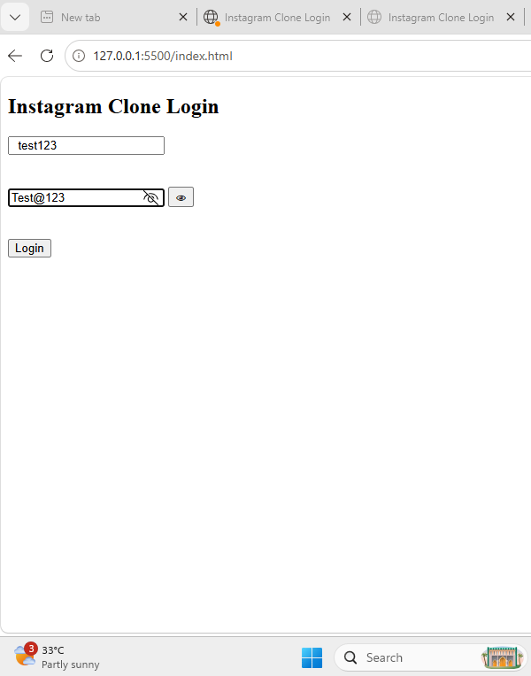
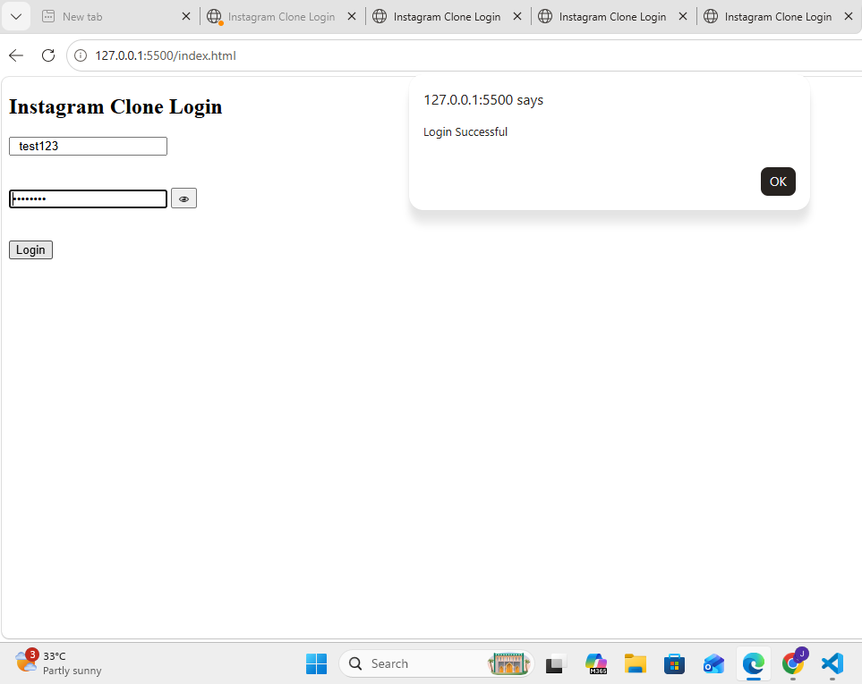

Scenario ID: 2a

Scenario: SQL Injection Test

Test Steps:

- Enter SQL Injection String.
- Click Login.

Test Input:

' OR '1'='1

Expected Result:

Login should fail.

Actual Result:

Login Failed.

Status:

PASS

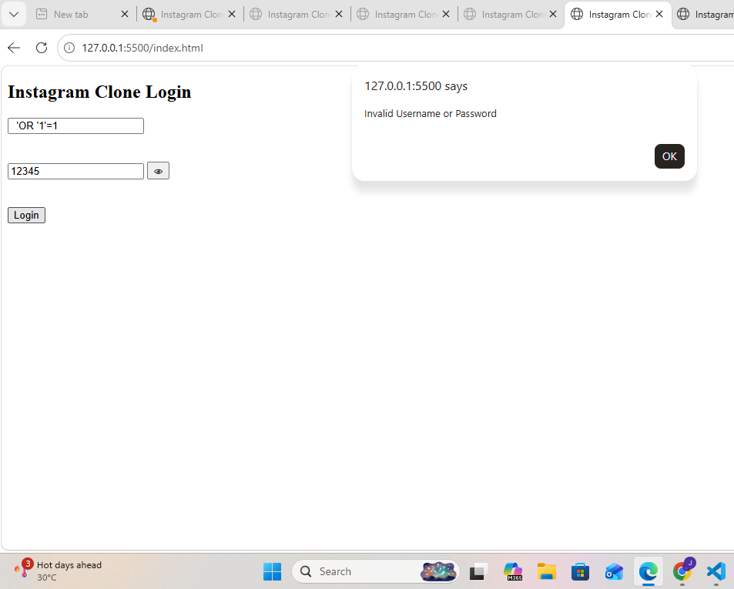

Scenario ID: 2b

Scenario: Login with Special Characters

Test Steps:

1.Enter Special Characters.
2.Click Login.

Test Input:

@#$%^&*

Expected Result:

Validation message displayed.

Actual Result:

Validation message displayed.

Status:

PASS
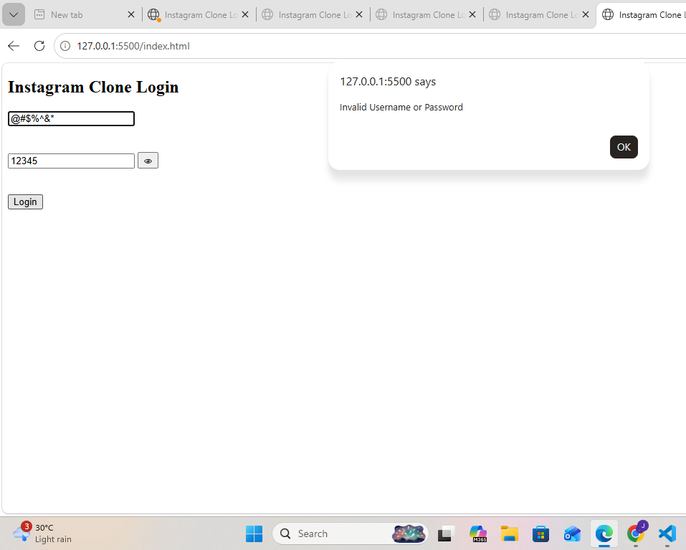

Scenario ID: 2c

Scenario: Login with Long Username

Test Steps:

- Enter Username longer than allowed.
- Click Login.

Test Input:

100+ Character Username

Expected Result:

Validation message displayed.

Actual Result:
Validation message displayed.

Status:

PASS

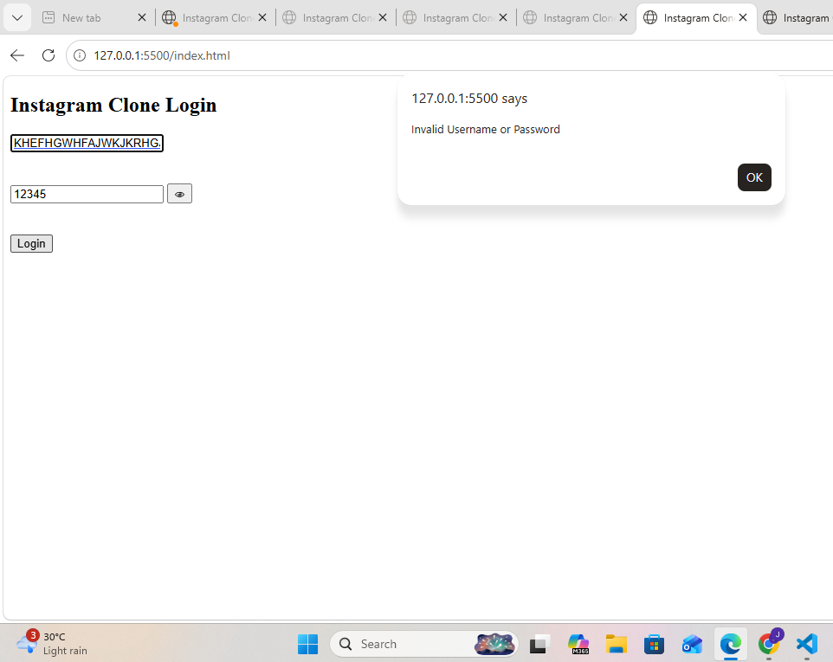

Scenario ID: 2d

Scenario: Refresh After Login

Test Steps:
- Login Successfully.
- Refresh Browser.

Test Input:

Valid Credentials

Expected Result:

User remains logged in.

Actual Result:

User remains logged in.

Status:

PASS

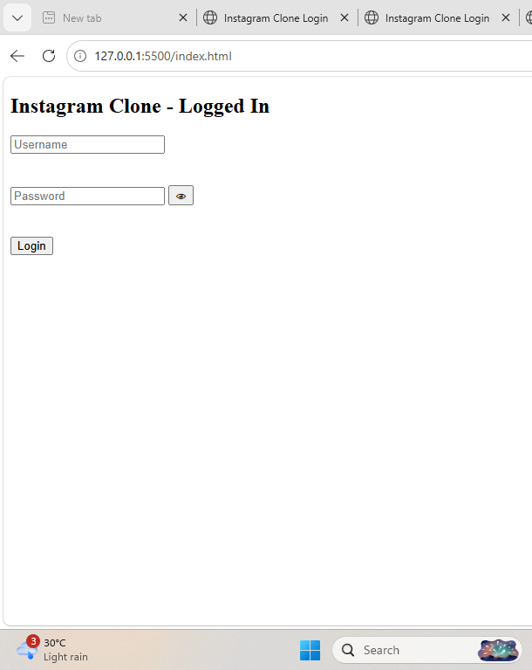

Scenario ID: 2e

Scenario: Logout Functionality

Test Steps:

- Login.
- Click Logout.

Test Input:

Logged-in User

Expected Result:

Redirect to Login Page.

Actual Result:

Redirected Successfully.

Status:

PASS

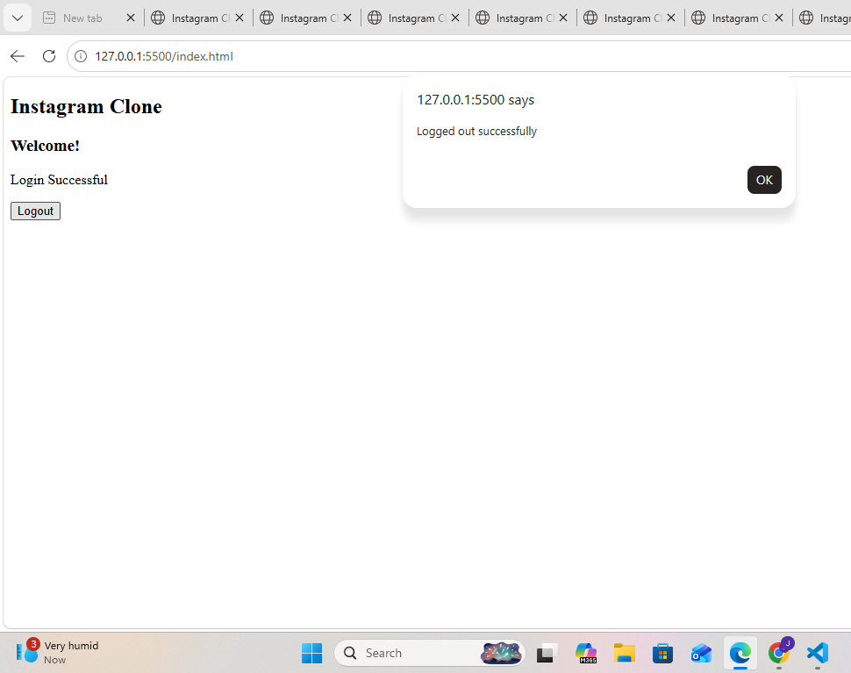
Scenario ID: 3a

Scenario: Logout from Dashboard

Test Steps:

- Login to app.
- Click on Profile/Dashboard.
- Click on Logout.

Test Input:

Logged-in session

Expected Result:

User is logged out and redirected to Login page.

Actual Result:

User is logged out and redirected to Login page.

Status:

PASS

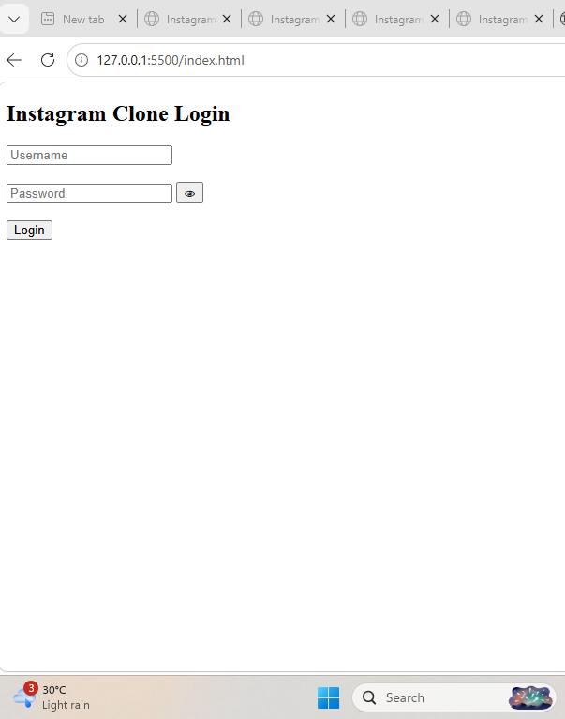

Scenario ID: 3b

Scenario: Logout via Back Button

Test Steps:

- Login to app.
- Click Logout.

Press browser Back button.

Test Input:

Logged-in session

Expected Result:

User should remain logged out and should not return to Dashboard.

Actual Result:

User remains logged out and does not return to Dashboard.

Status:

PASS

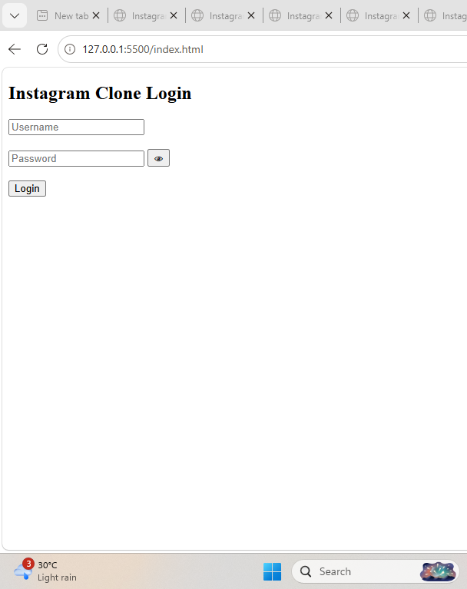

Scenario ID: 4a

Scenario: Check Button Alignments

Test Steps:

- Open Login Page.
- Observe button placements.

Test Input:

None

Expected Result:

All buttons are properly aligned.

Actual Result:

All buttons are properly aligned.

Status:

PASS

Scenario ID: 4b

Scenario: Check Color Contrast

Test Steps:

- Open Login Page.
- Observe text, input fields and buttons.

Test Input:

None

Expected Result:

Text and buttons are clearly visible with good contrast.
Actual Result:

Text and buttons are clearly visible with good contrast.

Status:

PASS

Scenario ID: 4c

Scenario: Check Input Field Spacing

Test Steps:

- Open Login Page.
- Observe spacing between Username and Password fields.

Test Input:

None

Expected Result:

Sufficient spacing is provided between input fields.

Actual Result:

Sufficient spacing is provided between input fields.

Status:

PASS

Scenario ID: 4d

Scenario: Visual Feedback on Click

Test Steps:

- Open Login Page.
- Click on Username and Password fields.
- Click on Login button.

Test Input:

test123 / Test@123

Expected Result:

Buttons and input fields provide visual feedback on interaction.

Actual Result:

Input fields and Login button respond to user interaction.

Status:

PASS

